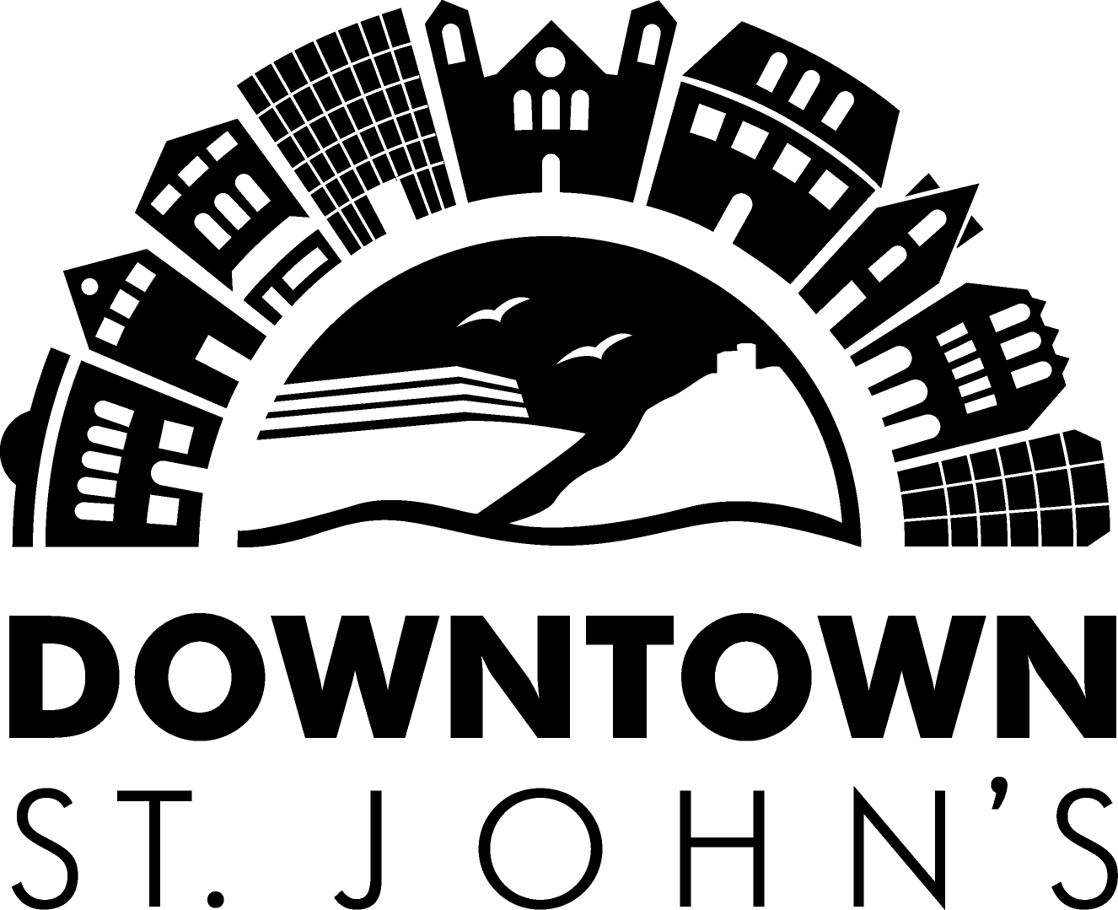

Purpose

The Facade Improvement Project is intended to improve the downtown experience for residents, workers, and visitors alike. The project is aiming to help building owners attract and retain tenants, build civic pride among the local business community, and overall, promote the marketability of the downtown St. John's Business district.

Financial Assistance

Downtown St. John's Business Commission (Downtown St. John’s) will review all applications on an on-going basis. Applications can be emailed or dropped off in person to the Downtown St. John’s office at 140 Water Street, Suite 705. Please do not mail or fax applications. Funds will be distributed until the 2025 budget allocation has been depleted, at which point no new applicants will be approved for funding in 2025.

Applications including written cost estimates, photos of proposed project site (can be emailed), design plans must be submitted to Downtown St. John's prior to the commencement of any work. Upon review, a Letter of Agreement will be issued detailing terms of conditions and amount of funding approved. Payment of claims will be contingent upon work completion, submission of detailed Claim Form (provided with Letter of Agreement) and copies of all invoices and cancelled cheques to Downtown St. John's.

Time Frame

Funded projects should be completed by December 31, 2025. Applications will be taken until current calendar year funding is gone. Please note that applications must be received and reviewed by the Facade Improvement Committee before facade construction begins. Grants will not be awarded to facade improvement projects’ that are under construction or already completed.

Facade Improvement Committee

The committee will review applications based upon the projects overall benefits to the Downtown and its impact on increased aesthetic appeal and property value. Projects that are recommended for approval by the committee will be submitted to the Board of Directors for approval. In all cases, the decision of the Facade Improvement committee is final. Applications that are denied by the committee may be re-submitted the following calendar year.

Disclaimer

Neither Downtown St. John's nor the Facade Improvement project Committee, nor its affiliates shall be responsible for the planning, design, or construction of improvements to property that is owned by the applicant. No warranties or guarantees are expressed or implied by the description of, application for, or participation in the Facade Improvement project. The applicant is advised to consult with licensed architects, engineers, or building contractors before proceeding with final plans or construction.
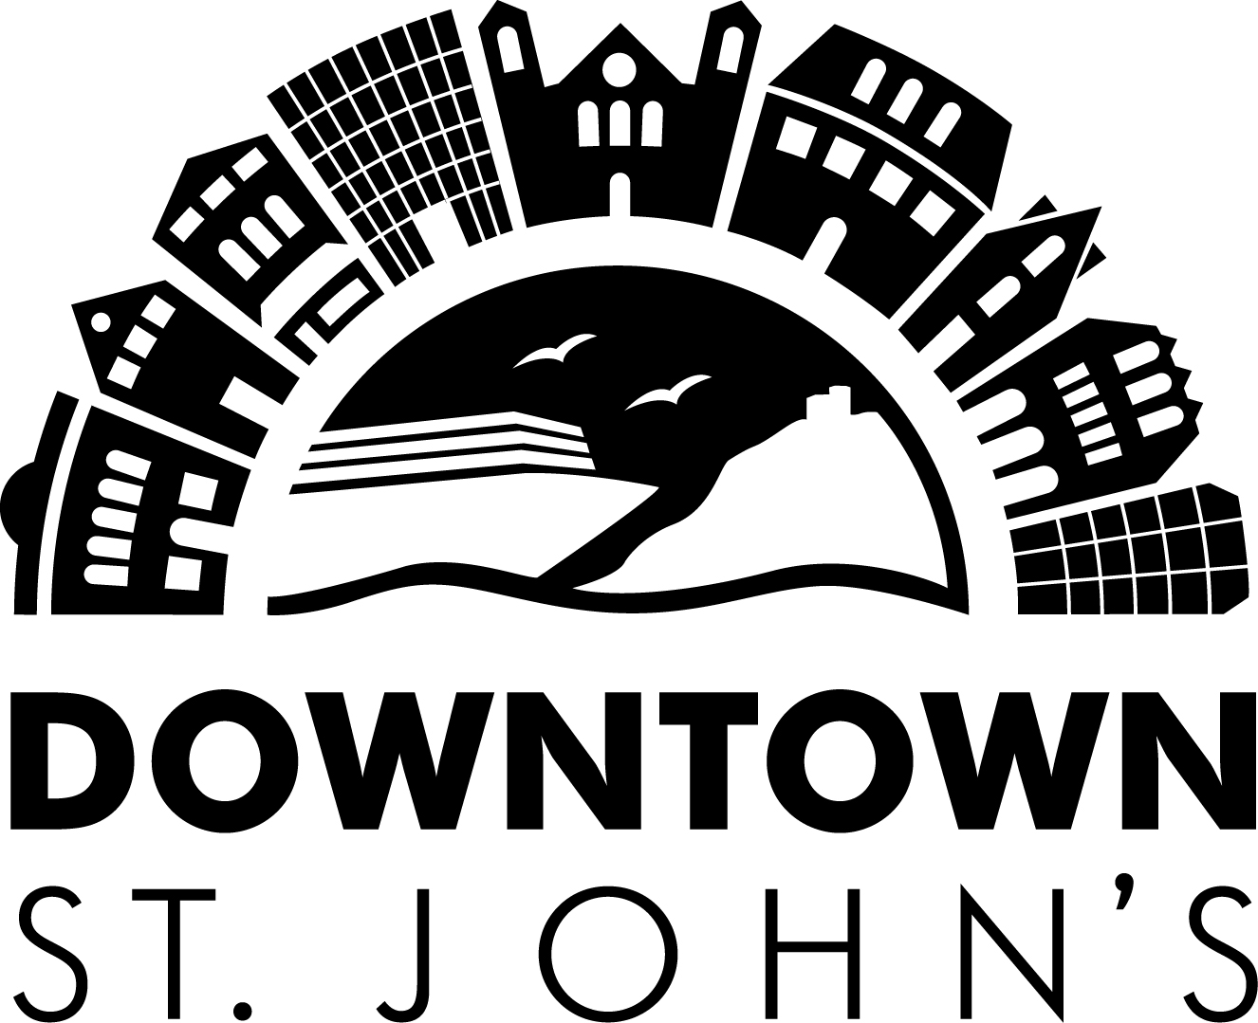

Submittals

Applications must include the following materials, if applicable, for consideration by the Facade Improvement Committee. Applicants that do not include applicable information will not be considered. Please provide materials that can be reproduced for distribution to the committee:
a) Current photo(s) of the proposed project site – original color copies can be emailed to info@downtownstjohns.com
b) Rendering or sketch of proposed improvements – if applicable
c) Architectural plans, including dimensions/measurements
d) Color and materials samples for paint, awning, signs, etc.
e) Sign plans
f) Awning design
g) Historical significance designation

Estimated Costs and Timing

Please provide copies of vendor bids/estimates or other documentation of cost estimates for all proposed facade work.

a. Water clean exterior $ _________________
b. Exterior prep and paint $ _________________
c. Window replacements/repair $ _________________
d. Door replacement/Foyer repairs $ _________________
e. Exterior Lighting $ _________________
f. Facade restoration/rehabilitation $ _________________
g. Architectural /Design fees $ _________________
h. Landscape/hardscape improvements $ _________________
i. Bulding permit/planning fees $ _________________
j. Other proposed Improvements (specify) $_________________
k. Signage $ _________________
i. Awnings $ _________________

Subtotal $ _________________
TOTAL ESTIMATED COST $ _________________

Estimated Date of Completion __________________________

Signatures

Signed: ________________________ Signed: ________________________

Property Owner(s) Signature(s) Applicant(s) Signature(s)

Approval (office use only)
Amount approved: _____________________ Date approved: ________________________
Approved by: __________________________ Executive Director Downtown St. John's

